ML Introduction

1. What is machine learning?

It is a set of algorithms to make machines learn from the data, predict the trend and take decisions.

1. Machine learning models
   1. Supervised Learning

Labelled data (tagged data, sample input and output are there) is fed to algorithm

* + 1. Classification: Output variable is a category (discrete). Example Algorithm: Logistic Regression, K-Nearest Neighbors, Random Forest, Support Vector Machines, Decision Tree Classification, Naïve Bayes
    2. Regression: Output variable is a numerical value (continuous). Example Algorithms: Simple Linear Regression, Multiple Linear Regression, Polynomial Linear Regression, Support Vector Regression, Decision Tree Regression, Random Forest Regression
  1. Unsupervised Learning

Algorithms can solve their own problem (data is not labelled, we do not know the output of data). Unsupervised machine learning helps you to finds all kind of unknown patterns in data.

* + 1. Clustering: is the task of grouping a set of objects in such a way that objects in the same group (called a cluster) are more similar (in some sense) to each other than to those in other groups (clusters). Example Algorithms: K-means clustering, Hierarchical Clustering, K-NN (k nearest neighbors)
    2. Association: Finds interesting associations and relationships among large sets of data items. Example: Support (how frequent an item occurs), Confidence (how likely item Y is purchased when item X is purchased), Lift (how likely item Y is purchased when item X is purchased, while controlling for how popular item Y is)

<https://www.kdnuggets.com/2016/04/association-rules-apriori-algorithm-tutorial.html>

* 1. Reinforcement Learning

Algorithms learn from environment in iterative process and need reward feedback to learn and fine tune its behavior.

1. Training Data vs Test Data

Training Data: Contains both input and expected output. Used to train the algorithm.

Test Data: Contains just the input and tests how well the algorithm was trained.

1. Stages in Machine Learning Life Cycle

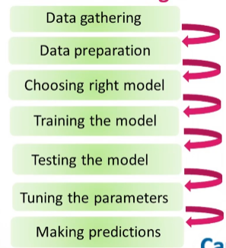

1. Dealing with large data files

* Increase memory of the system
* Reconfigure tools and libraries
* Decrease the size of data set
* Convert to memory saving data format
* Use RDBMS
* Harness the power of Big Data platforms

1. Supervised vs Unsupervised learning

Supervised learning refers to a type of Machine learning in which the machine requires external supervision for learning from data. It contains the models which are trained using the labeled dataset. Moreover, it solves problems like regression and classification.

On the other hand, unsupervised learning refers to a type of machine learning in which the machine does not require any external supervision for learning from the data. This can be trained using the unlabelled dataset. And, it using for solving problems like association and clustering problems.

1. AI

AI contains the algorithms and techniques for enabling a machine to perform the tasks commonly linked with human intelligence. The AI applications are trained for processing large amounts of complex information and right decisions without human intervention.

Data Preprocessing

Refer program Preprocessing.py

The following steps are to be followed for supervised learning (regression, classification, ANN) (For unsupervised, use what is required out of these steps, refer individual sections of unsupervised):

1. Import the dataset and bifurcate the dependent and independent variables
2. Take care of missing data (one of the following or combination can be used)
   1. Delete the entire row if there is missing data – works fine when you have large dataset and only few of the data is missing
   2. Replace the missing value by the average of the column
3. Encode the categorical data

This is required because categorical data is not numerical and we need to convert it into some sort of numerical value

* 1. Encode the categorical independent variable
  2. Encode the categorical dependent variable

1. Splitting the dataset into training set and test set
2. Feature scaling

* Not required in every model
* This is to make sure that none of the features start dominating the prediction
* Goal is to have value for all the features within a specific range
* Should be applied to all columns (**dependent + independent**) except the dummy columns or the ones that are already within standard or normal range

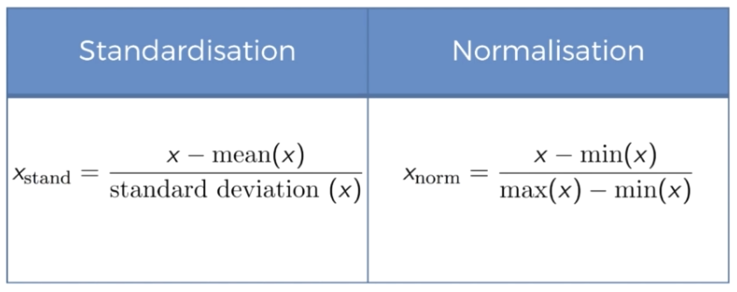

Standardization will put every value in between -3 and +3. Works well all the time.

Normalization will put every value in between 0 and 1. Should be chosen when most of the features have normal distribution

* **Should we apply feature scaling before or after splitting the dataset into training set and test set?**

Feature scaling has to be applied after splitting the dataset into training set and test set. The reason is very simple – test data is something that our model should completely be unaware of. If we do feature scaling first, it would cause information leakage (because feature scaling requires calculation such as mean, standard deviation, etc).

* **Do we need to apply feature scaling to the encoded column?**

No, they are already in the range of 0 and 1

**Features**: Columns that contain independent variables

**Dependent variable**: whose value depends on features (usually the last column, whose value we want to predict)

Regression

Assumptions of a Linear regression:

1. Linearity
2. Homoscedasticity
3. Multivariate normality
4. Independence of errors
5. Lack of multicollinearity

Simple Linear Regression

$$y = b_{0}+b_{1}x_{1}$$

* Same as y = mx + c
* It works on the principle of ordinary least square
* Tries drawing a lot of straight lines through the data, finds the sum of square of all the difference between actual value and the modeled value
* The line with least sum is the best fit
* No need of feature scaling as we only have one independent variable

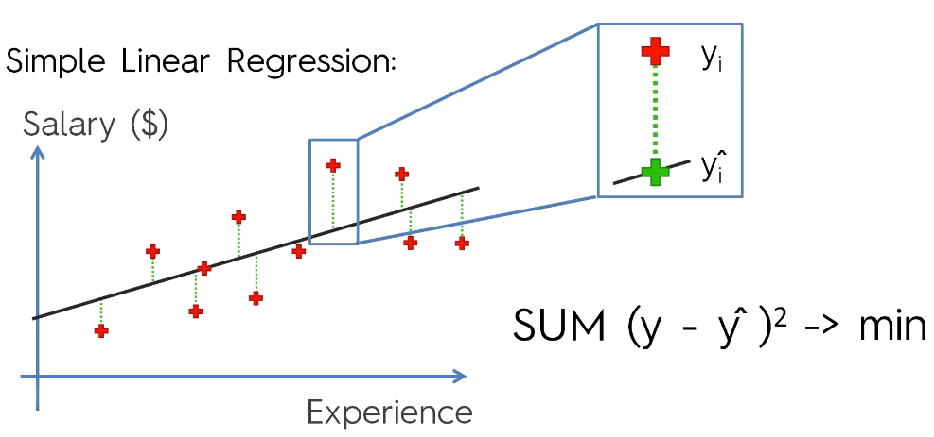

Multiple Linear Regression

$$y = b_{0}+ b_{1}x_{1}+ b_{2}x_{2} + b_{3}x_{3} +… + b_{n}x_{n}$$

No need to apply feature scaling as we already have coefficients with every dependent variable which will balance.

How to deal with categorical column: Dummy variables

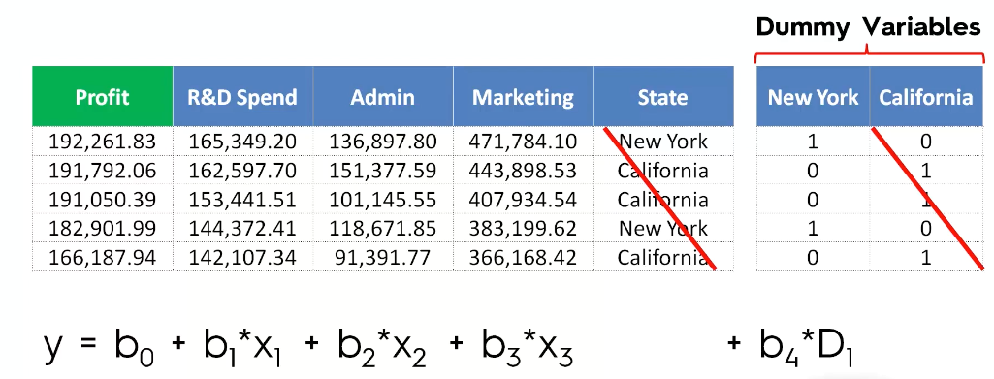

**Dummy variable trap**

Do not include both the variables for New York and California, take one and the other is automatically taken care of because New York = 1 - California

**Always omit one dummy variable. If you have 10 dummy variables, use 9 in the equation (sklearn automatically takes care of this)**

Feature Selection:

5 methods of building models (sklearn automatically does this, no extra code required):

1. All in
2. Backward Elimination
3. Forward Selection Stepwise Regression
4. Bidirectional Elimination
5. Score Comparison

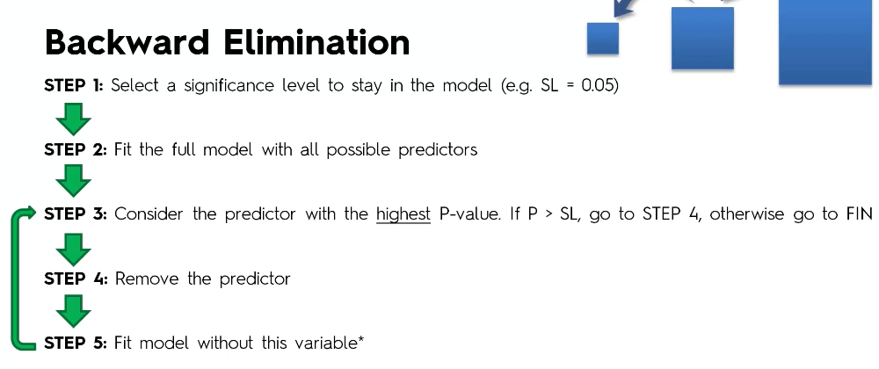

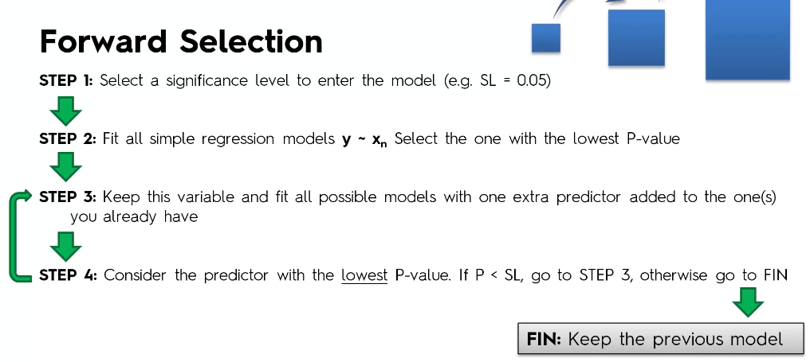

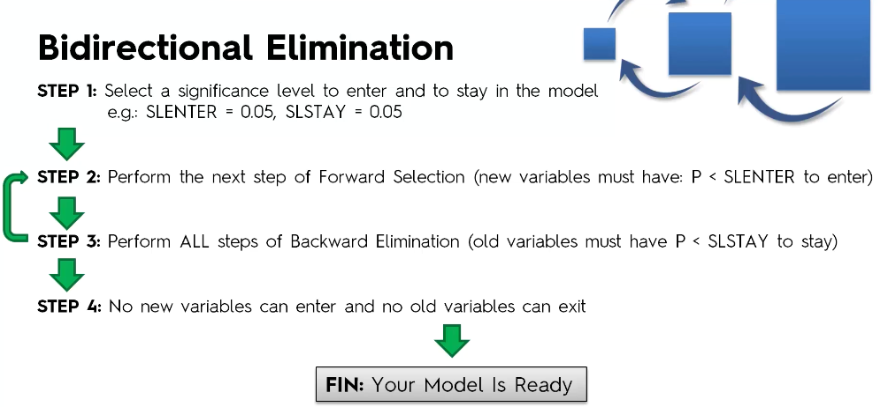

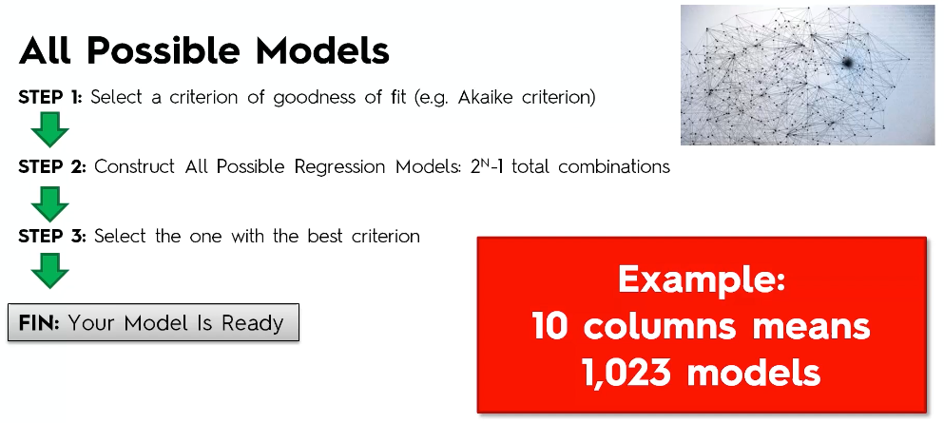

Polynomial Linear Regression

$$Y = b_{0} + b_{1}x + b_{2}x^{2}+…+b_{n}x^{n}$$

* It is a special kind of multiple linear regression
* Linear because we are focusing on power of coefficients and not the power of x
* Parameter tuning possible (what should be the degree of x)

Support Vector Regression (SVR)

* Outliers may be neglected
* Parameter tuning possible (what should be the SVM Kernel Function)
* Feature Scaling is a must here

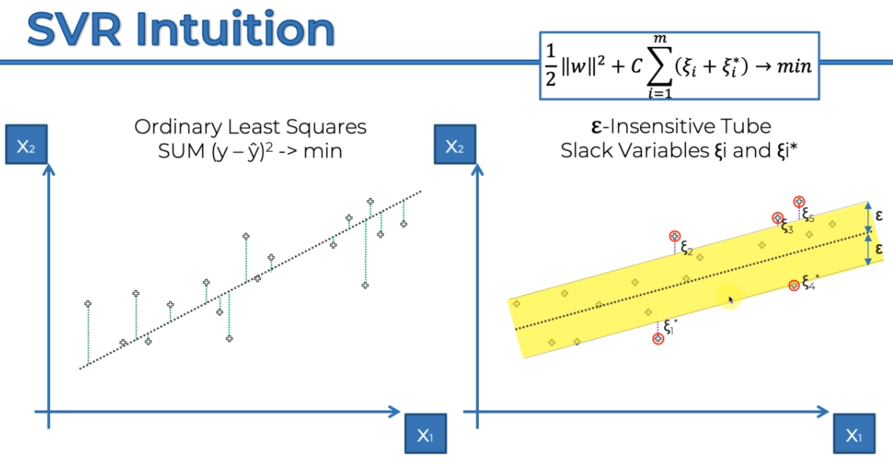

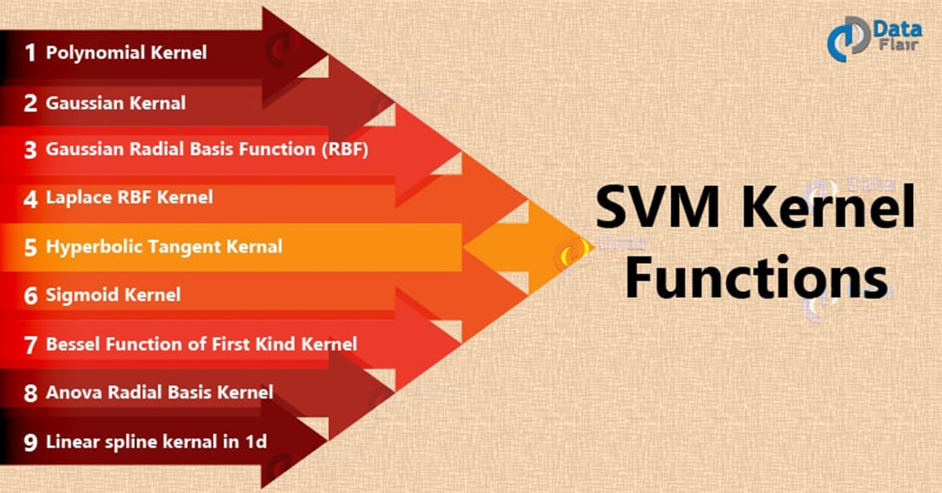

Refer <https://data-flair.training/blogs/svm-kernel-functions/> for SVM kernels

Decision Tree Regression

* Never apply feature scaling
* Suited for high dimensional datasets - which has lots of features (independent variables)
* Divide the data and create a decision tree out of it
* Leaf nodes have the average of points in a particular region

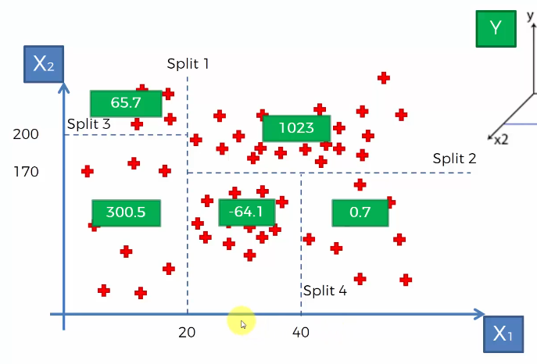

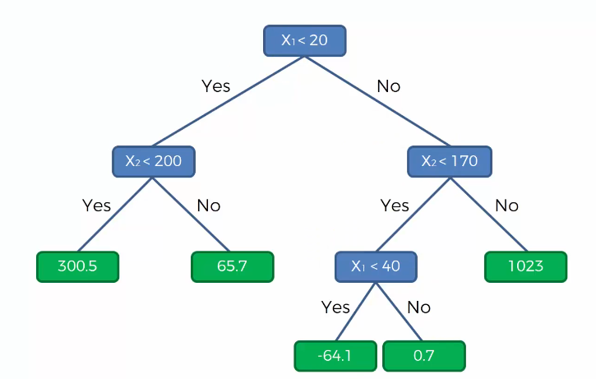

Random Forest Regression

* Never apply feature scaling
* Suited for high dimensional datasets - which has lots of features (independent variables)
* Built on top of Decision Tree
* Instead of having a single decision tree, create multiple decision trees by selecting k random points.
* Leaf nodes have average of all the points in that region
* Average of all the decision trees will give you the final prediction
* Parameter tuning possible (how many decision trees)
* **Random Forest Regression does not guarantee better result than Decision Tree Regression**

Performance - Regression Model

Goodness of fit is what we have to evaluate

R squared

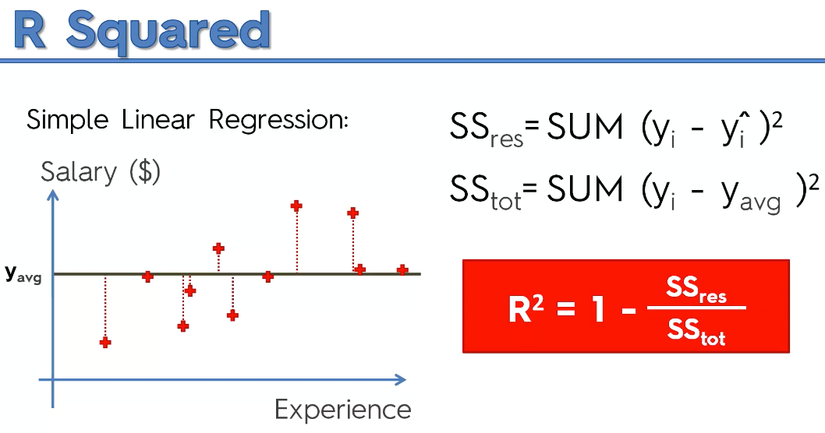

We are trying to get the least possible value of SS_res, closer to zero.

Aim is to get R^2 close to 1.

Closer the R^2 to 1, better the model.

R^2 = 1 means the best fit (ideal case – which is not possible in the real world)

If R^2 is negative, which again is not possible if regression models are used, but this indicates that your training is worse than the average fitted line.

The problem with R^2 is that adding a dependent variable can often improve the value with a very small amount, and this small improvement might not be cost effective as we are increasing the number of independent variables, hence next approach handles the goodness of fit in a better way.

Adjusted R squared

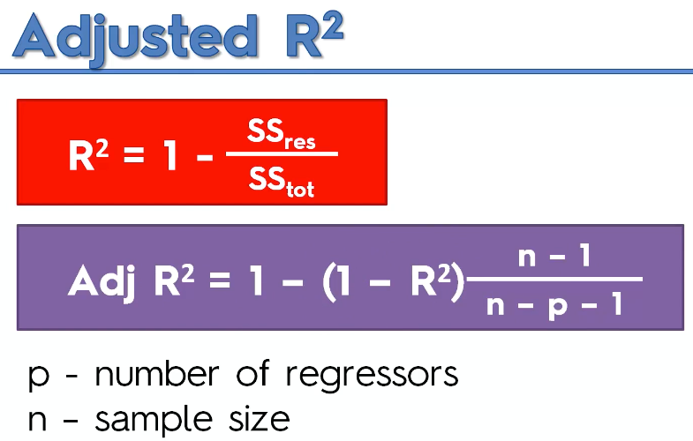

Takes care of the increase in number of independent variables (p) as well, along with the improvement in R^2.

Classification

Logistic Regression

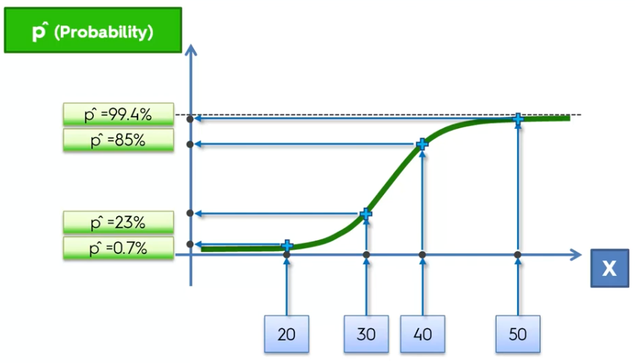

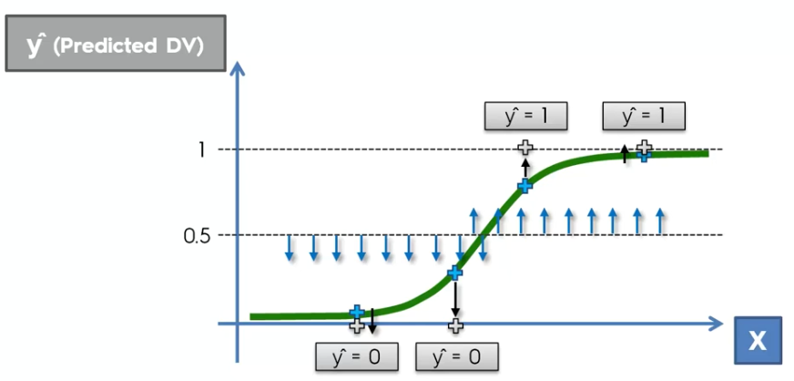

* Logistic Regression is a linear classifier and hence going to give a straight line for classifier

K-Nearest Neighbors (K-NN)

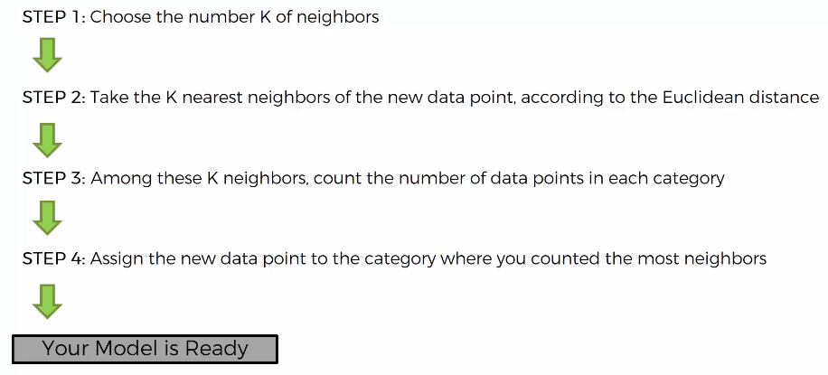

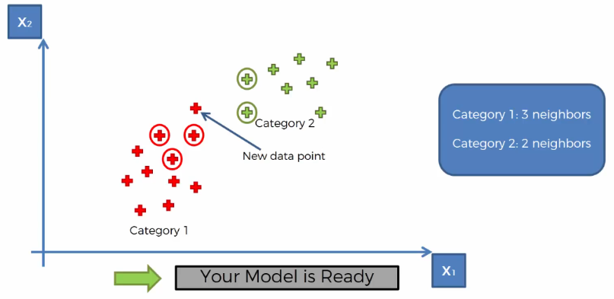

Here k = 5

Support Vector Machine (SVM)

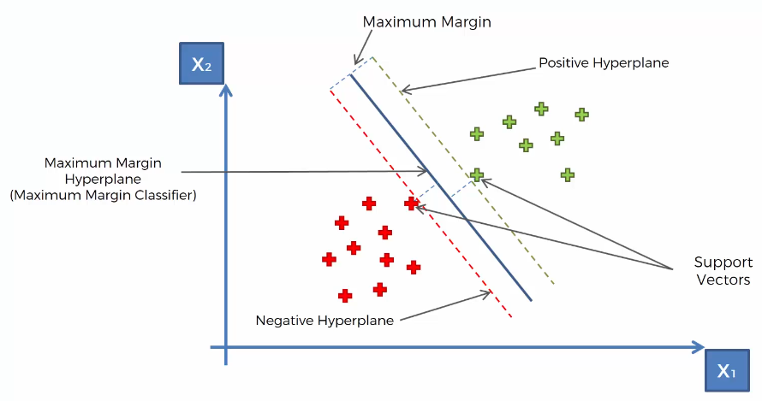

Kernel SVM

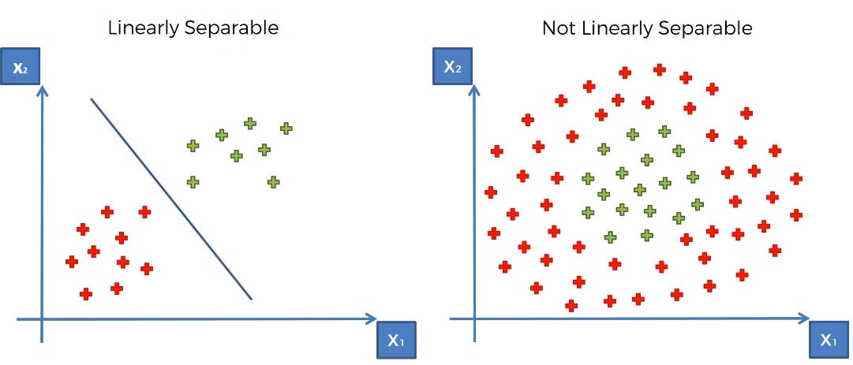

* So, what if the data is not linearly separable
* SVM would fail as we can’t draw a straight line of separation
* Two ways to handle this
  + Mapping to a higher dimension

This helps us to convert the non-linearly separable data into linearly separable data by adding extra dimension. But this can be highly compute-intensive

* + Kernel SVM

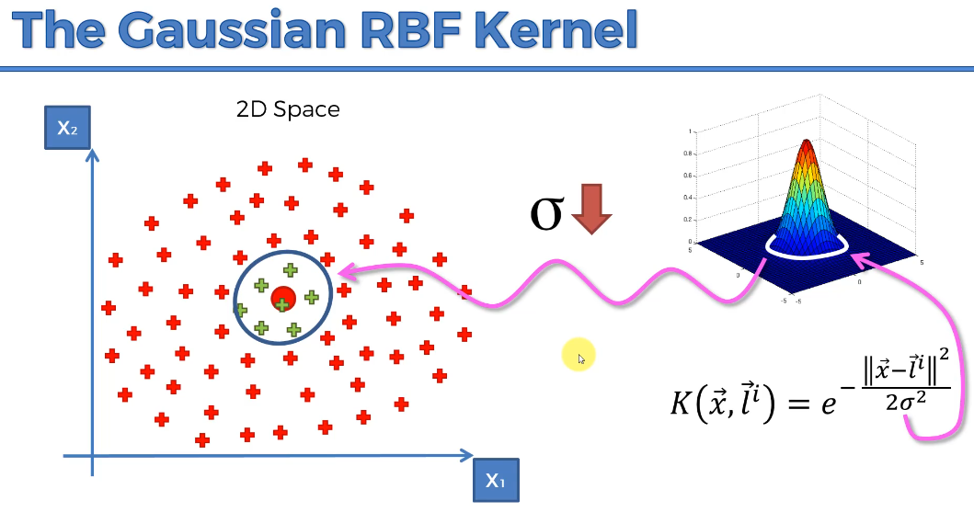

Most popular Kernel functions:

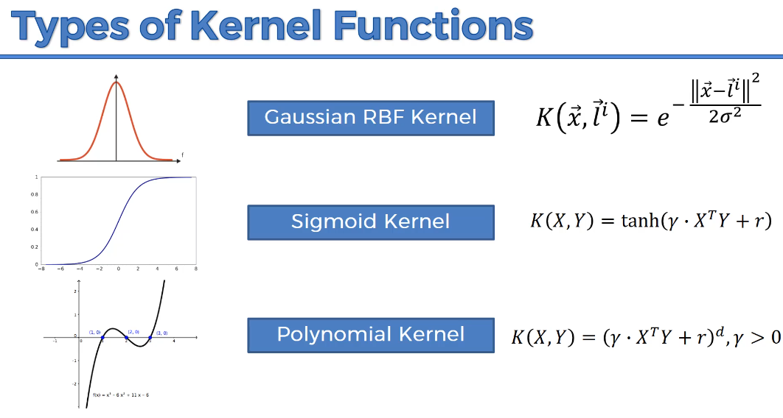

Naive Bayes

Based on bayes theorem

Bayes Theorem:

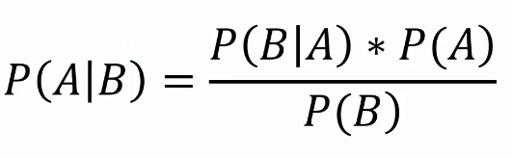

P(A | B) means probability of A given B

Example

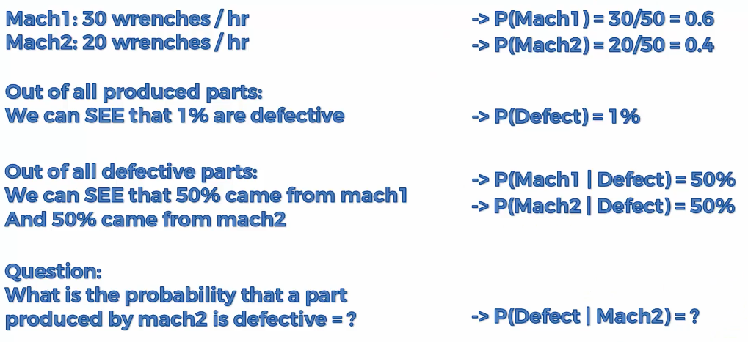

Decision Tree Classification

* Similar to Decision tree regression
* Here the focus is on classification, output variable is a class rather than numerical value
* Create decision tree and the leaves will have class value

Random Forest Classification

* Many decision trees together
* Multiple leaves will give class, consider the output as the class which occurs max number of times
* **Random Forest Classification does not guarantee better result than Decision Tree Classification**

Performance – Classification Model

False Positive and False Negative

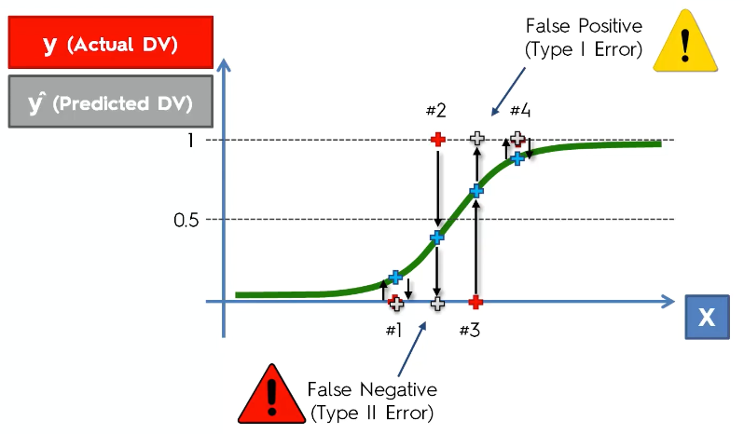

Confusion Matrix

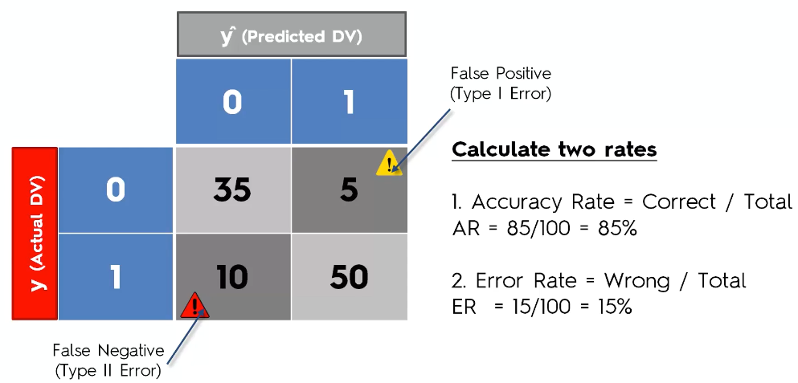

This is not the best way to evaluate performance as this can lead to **Accuracy Paradox**:

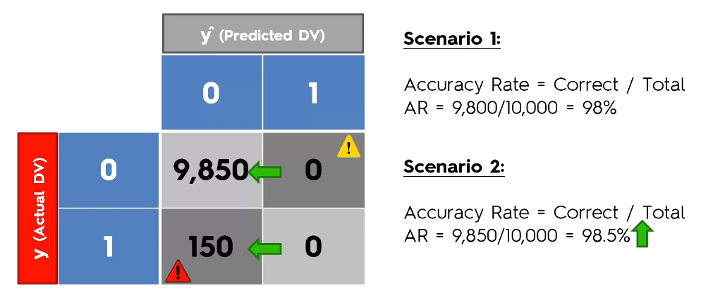

CAP – Cumulative Accuracy Profile

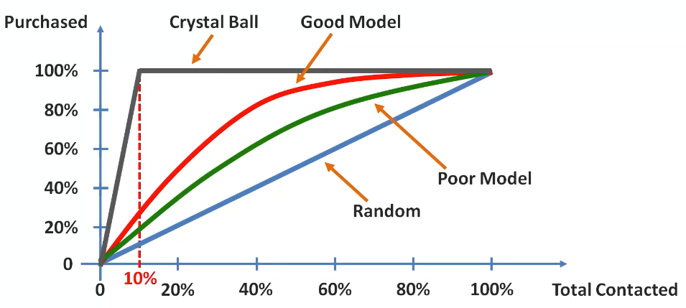

Note: CAP != ROC (Receiver Operating Characteristic)

**CAP Analysis:**

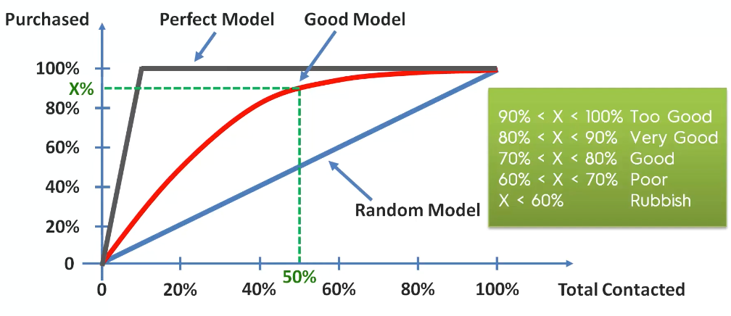

Remember, Accuracy is not enough, so we should also look at other performance metrics:

* Precision - measuring exactness
* Recall - measuring completeness
* F1 Score - compromise between Precision and Recall

Please find below these metrics formulas (TP = # True Positives, TN = # True Negatives, FP = # False Positives, FN = # False Negatives):

Accuracy = (TP + TN) / (TP + TN + FP + FN)

Precision = TP / (TP + FP)

Recall = TP / (TP + FN)

F1 Score = 2 * Precision * Recall / (Precision + Recall)

Clustering

* It is a type of unsupervised learning
* The aim is to find clusters (grouping) of related data – helps identify interesting pattern in data.
* Here, we only have independent variables
* **Note**: Clustering does not require splitting dataset into train set and test set, rest of the pre-processing remains same here as well

K-Means Clustering

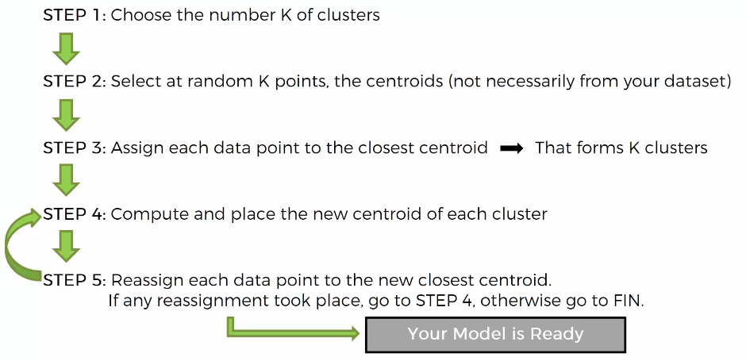

**Problem with K-Means Clustering**

* **Random Initialization Trap**

Selection of centroid at the very start of the algorithm can potentially dictate the outcome of the algorithm

To avoid this, use K-Means ++

Make sure the libraries you are using takes care of the random initialization trap.

**Choosing the right number of clusters**

Start with 1, calculate WCSS, then calculate WCSS for 2 and so on until WCSS keeps on decreasing

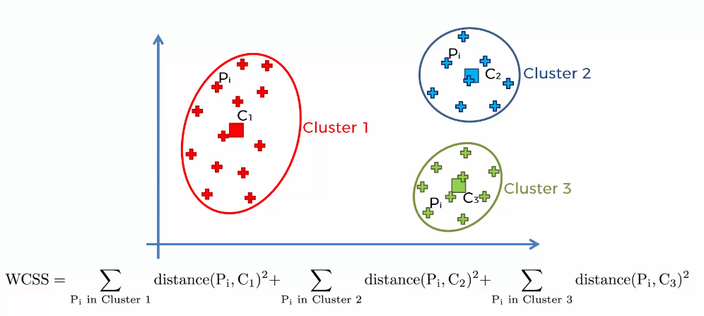

Lesser the WCSS, better the fit.

But what if number of clusters is equal to number of points. Then WCSS will be equal to zero. But, does this really help us? No, so when should we stop?

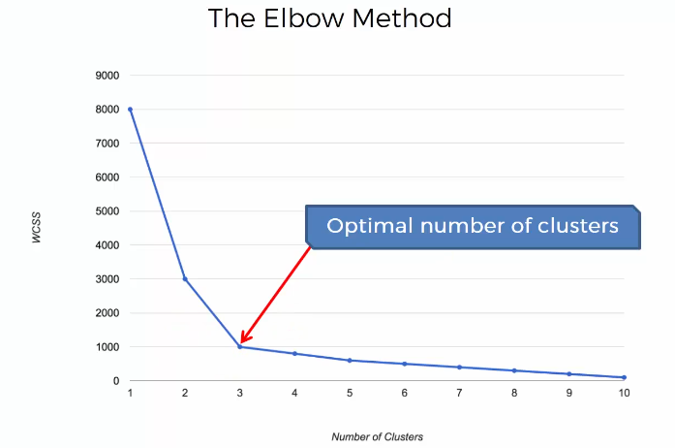

Hierarchical Clustering

Agglomerative

* Bottom-Up approach

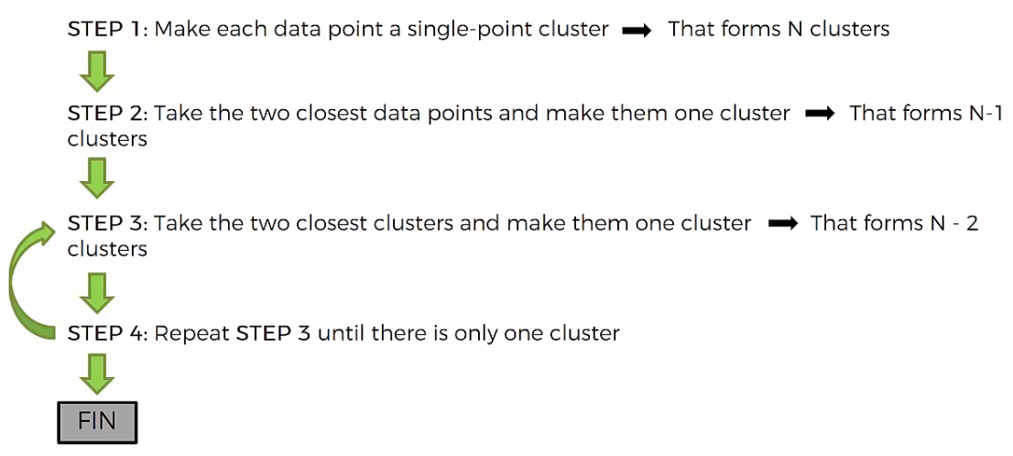

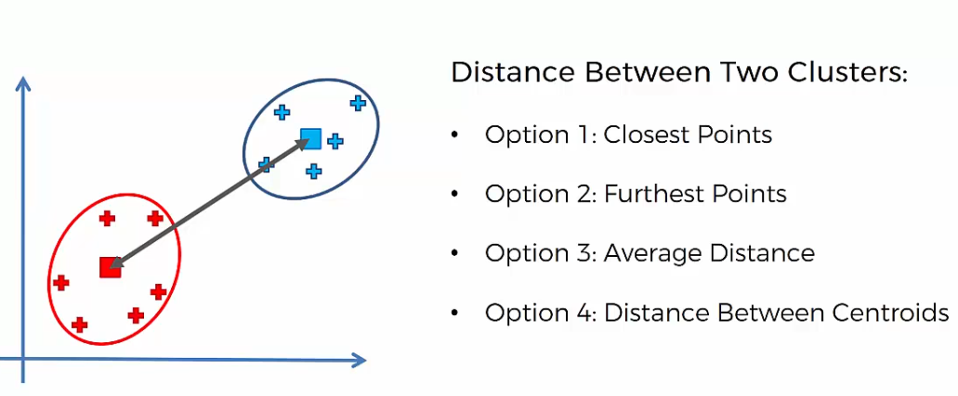

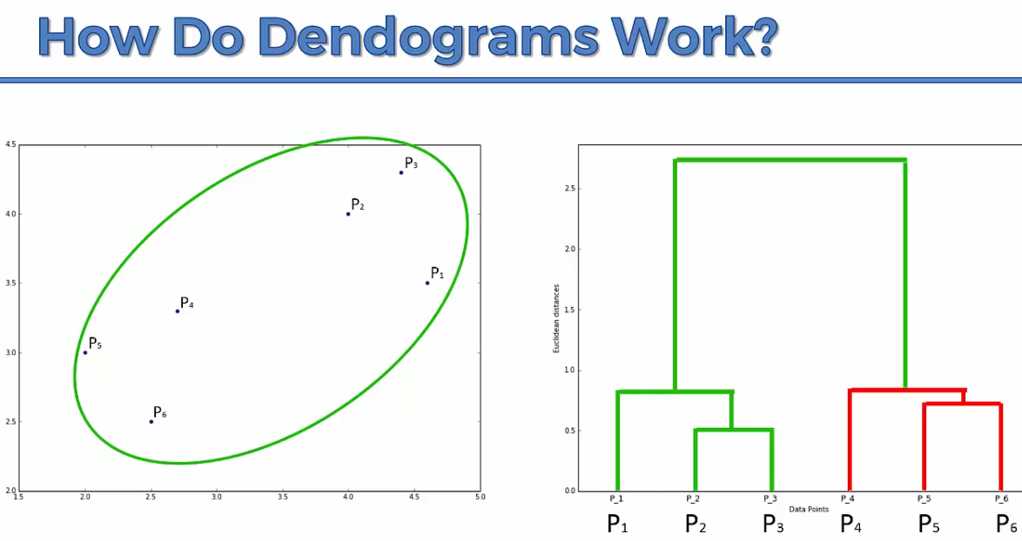

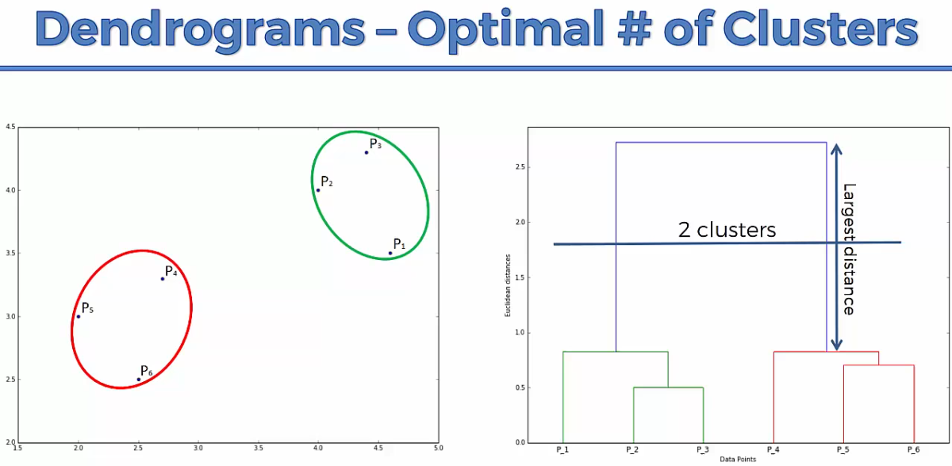

Select the largest vertical distance that does not cut through any other horizontal line. Place a horizontal line anywhere on the selected vertical line. Number of legs to this placed line is the number of clusters.

Divisive

* Top-Down approach

Model Selection

* Try both the models – K-Means as well as Hierarchical
* See if both are giving similar results
* If yes, then ok
* You can try out multiple possible values by looking at dendrogram of hierarchical clustering. See if you see any interesting pattern

Association Rule Learning

Apriori

<https://www.kdnuggets.com/2016/04/association-rules-apriori-algorithm-tutorial.html>

**Support**

* How frequent an item occurs?
* Like probability of occurrence of something

$Support\left(X\right)=\frac{no. of occurences of X}{total sample size}$

**Confidence**

* Given item X is purchased, how likely it is for item Y to be purchased

$Confidence\left(X→Y\right)=\frac{Support\left(X, Y\right)}{Support\left(X\right)}=\frac{no. of occurences of \left(X, Y\right)}{no. of occurences of X}$

**Lift**

* Given item X is purchased, how likely it is for item Y to be purchased, while controlling the popularity of item Y

$Lift \left(X→Y\right)= \frac{Support\left(X, Y\right)}{Support\left(X\right) * Support(Y)}=\frac{no. of occurences of \left(X, Y\right) * total sample size}{no. of occurences of X * no. of occurences of Y}$

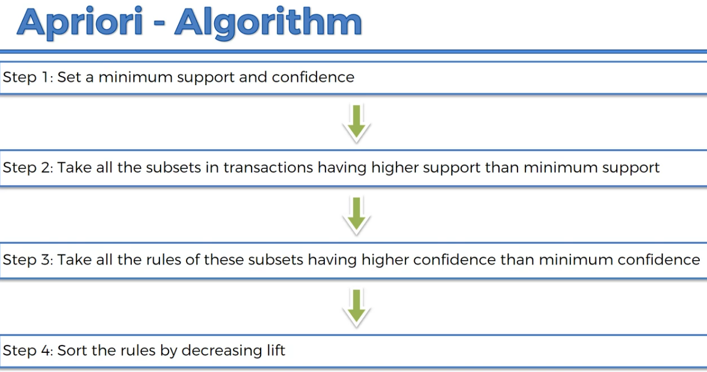

Eclat

* Not a very good model, Apriori should be considered
* We only have support here
* So, we look at set here instead of individual items
* So, support of X means X is a set of 2 or more items here

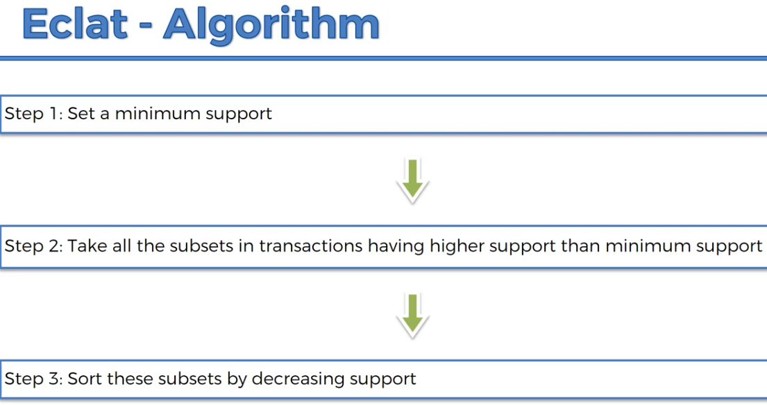

Model Selection

* Apriori works better as it also calculates confidence and lift, however it is slow compared to Eclat
* Apriori is useable with large datasets and Eclat is better suited to small and medium datasets

Reinforcement Learning

* Reinforcement Learning is a powerful branch of Machine Learning.
* It is used to solve interacting problems where the data observed up to time t is considered to decide which action to take at time t + 1.
* It is also used for Artificial Intelligence when training machines to perform tasks such as walking.
* Desired outcomes provide the AI with reward, undesired with punishment. Machines learn through trial and error.

First explore all the available solutions, figure out which one is best and then start exploiting it. Careful, do not spend a lot of time exploring, otherwise you will lose significant time in figuring out the best. Also, not exploring enough is dangerous too because this can give us solution which is not best.

Upper Confidence Bound (UCB)

Very popular algorithm in online advertising and digital marketing.

Thompson Sampling

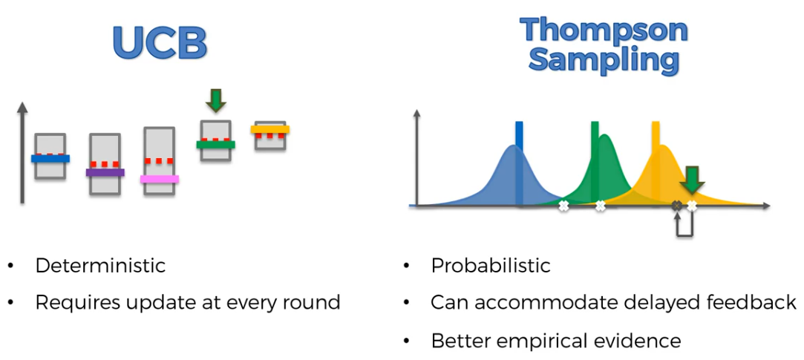

Model Selection

* Thompson Sampling performs better in most of the cases
* However, try running both and see which one is able to figure out in less rounds (decrease the number of rounds (N), run both and see which one is capable of showing same result as it did after all the rounds)

NLP

* Natural Language Processing (or NLP) is applying Machine Learning models to text and language.
* Teaching machines to understand what is said in spoken and written word is the focus of Natural Language Processing.
* Whenever you dictate something into your iPhone / Android device that is then converted to text, that’s an NLP algorithm in action.
* You can also use NLP on a text review to predict if the review is a good one or a bad one.
* You can use NLP on an article to predict some categories of the articles you are trying to segment.
* You can use NLP on a book to predict the genre of the book.
* And it can go further, you can use NLP to build a machine translator or a speech recognition system, and in that last example you use classification algorithms to classify language.

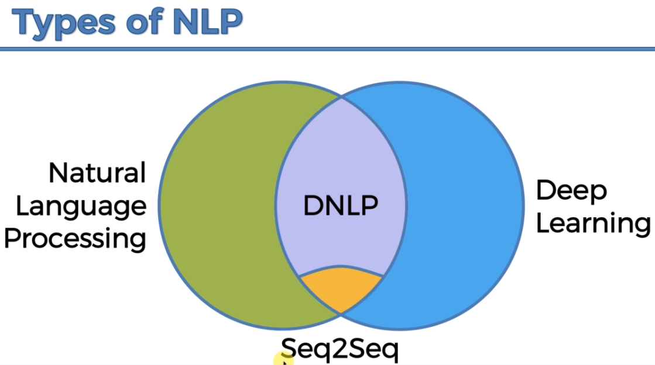

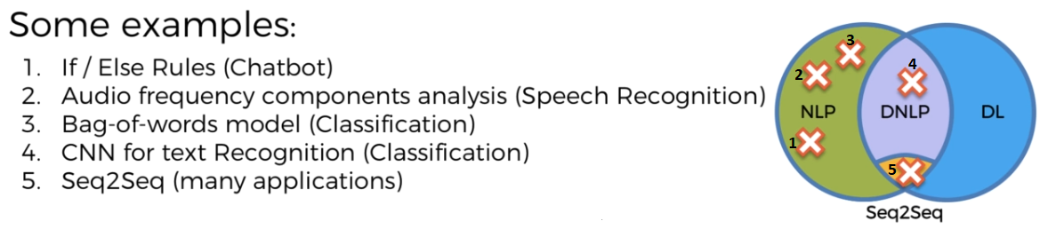

Deep Learning

Deep Learning is the most exciting and powerful branch of Machine Learning. Deep Learning models can be used for a variety of complex tasks:

* Artificial Neural Networks for Regression and Classification
* Convolutional Neural Networks for Computer Vision
* Recurrent Neural Networks for Time Series Analysis
* Self-Organizing Maps for Feature Extraction
* Deep Boltzmann Machines for Recommendation Systems
* Auto Encoders for Recommendation Systems

Artificial Neural Network

* ANN is used for supervised learning only
* So, same data pre-processing as involved in supervised learning

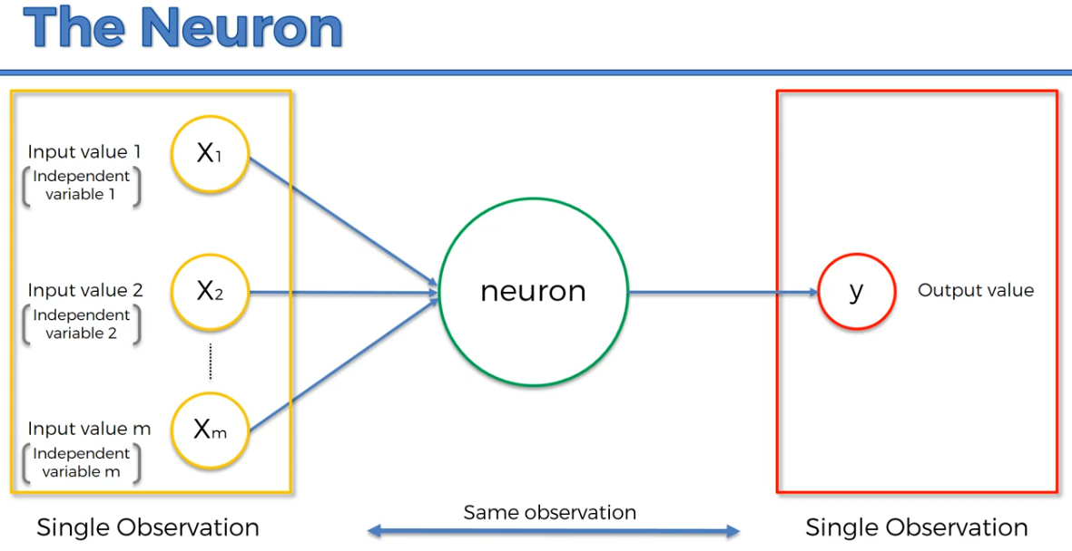

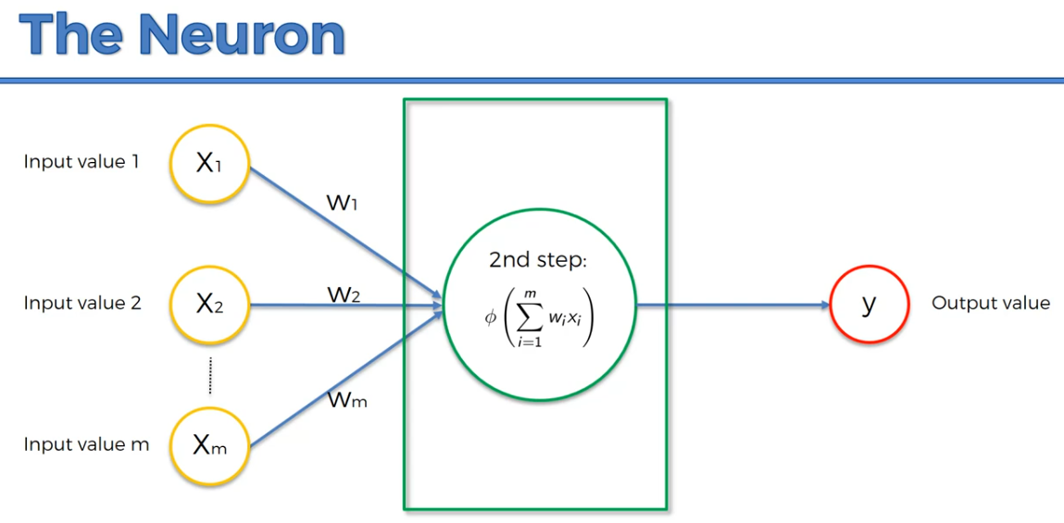

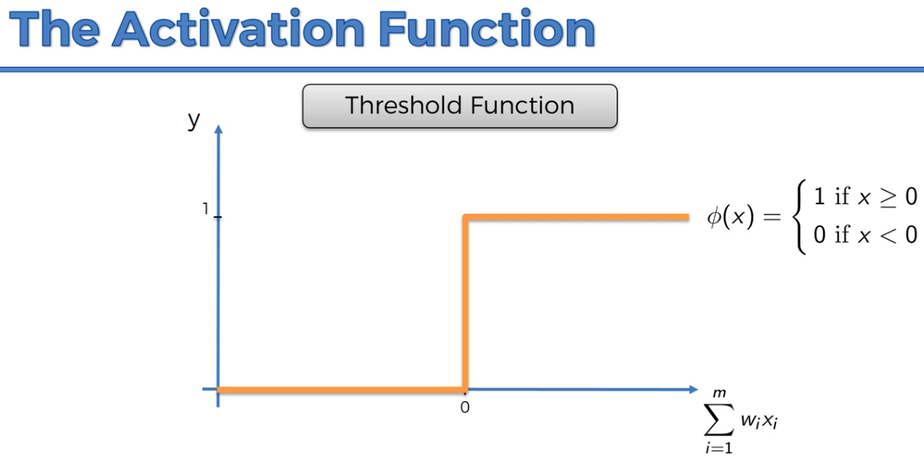

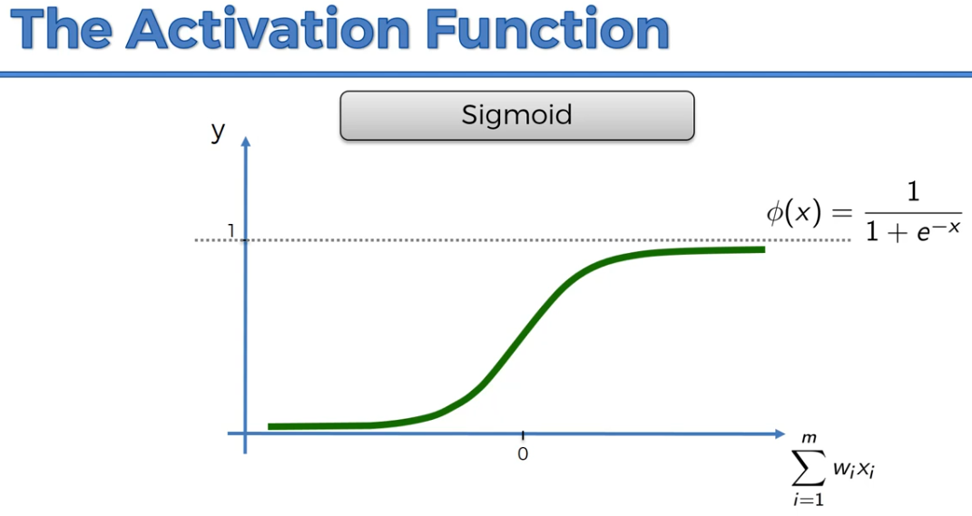

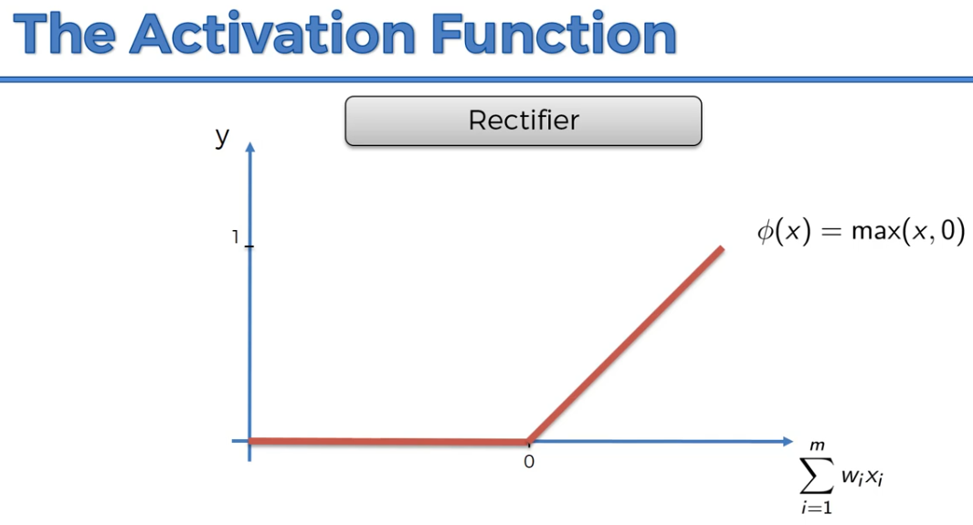

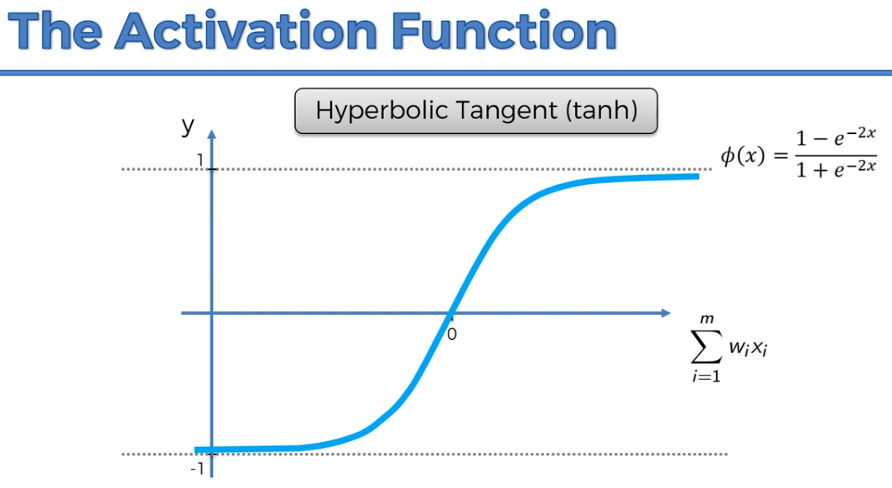

Most used activation function:

* For hidden layer: Rectifier
* For output layer: Sigmoid

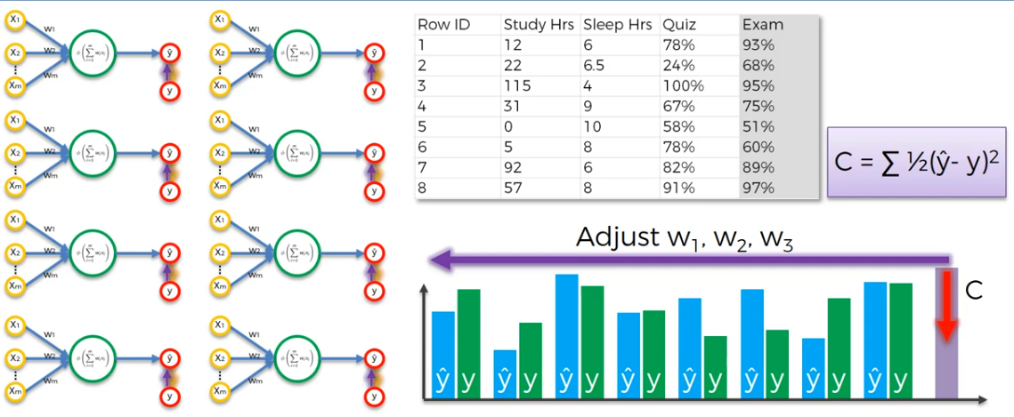

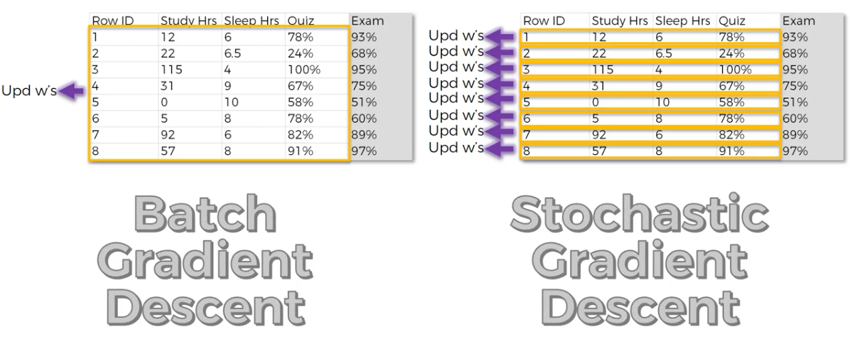

Stochastic Gradient helps us to avoid local minima which can result in unoptimized neural network.

Backpropagation helps us to adjust all of weights at the same time.

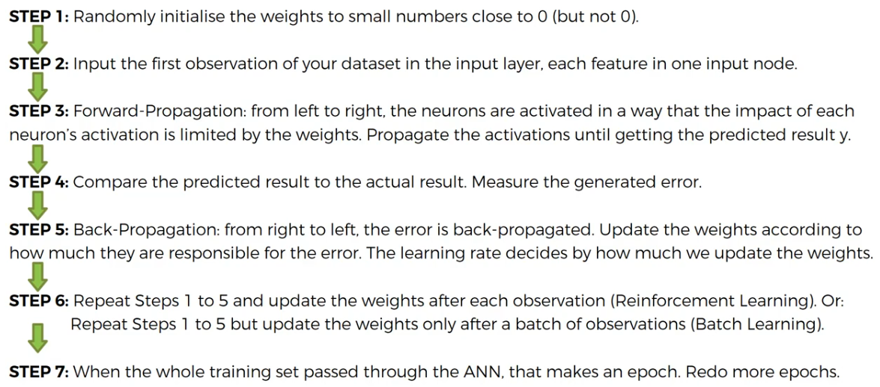

Convolutional Neural Network

* The primary goal of convolution is to find features in your image using the feature detector and put them in a feature map

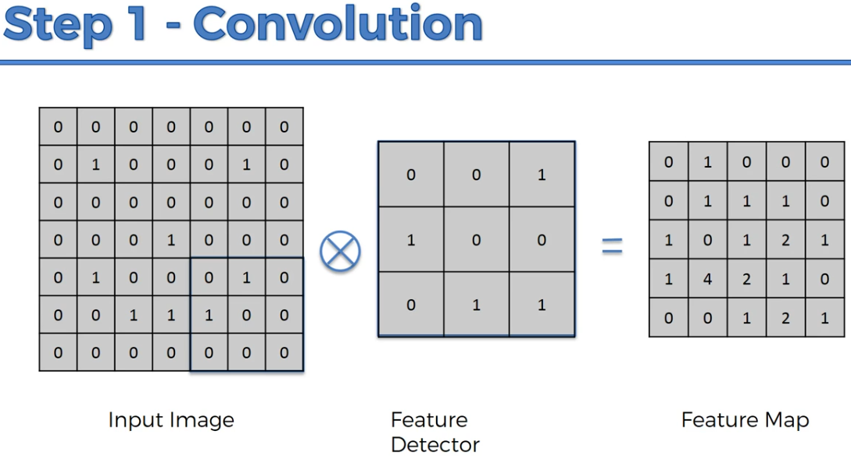

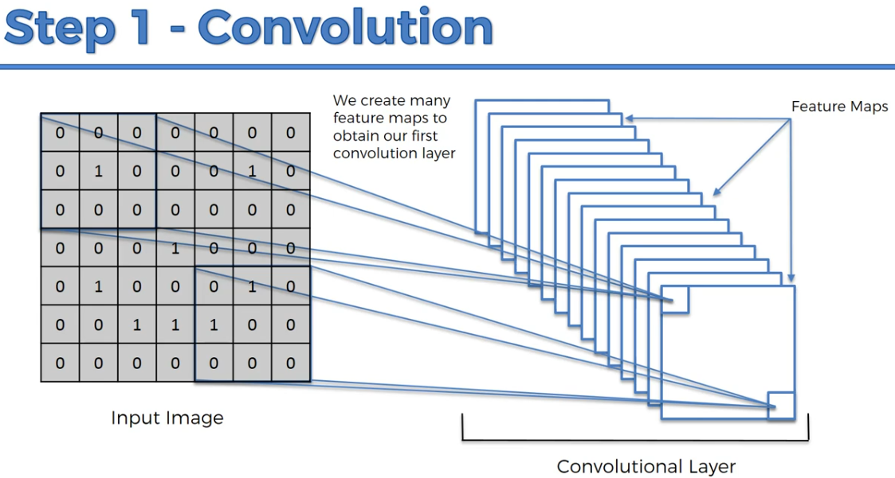

ReLU layer focuses on breaking the linearity which could be introduced by convolution. Generally images are highly non-linear, convolution can introduce linearity which can be removed by ReLU layer.

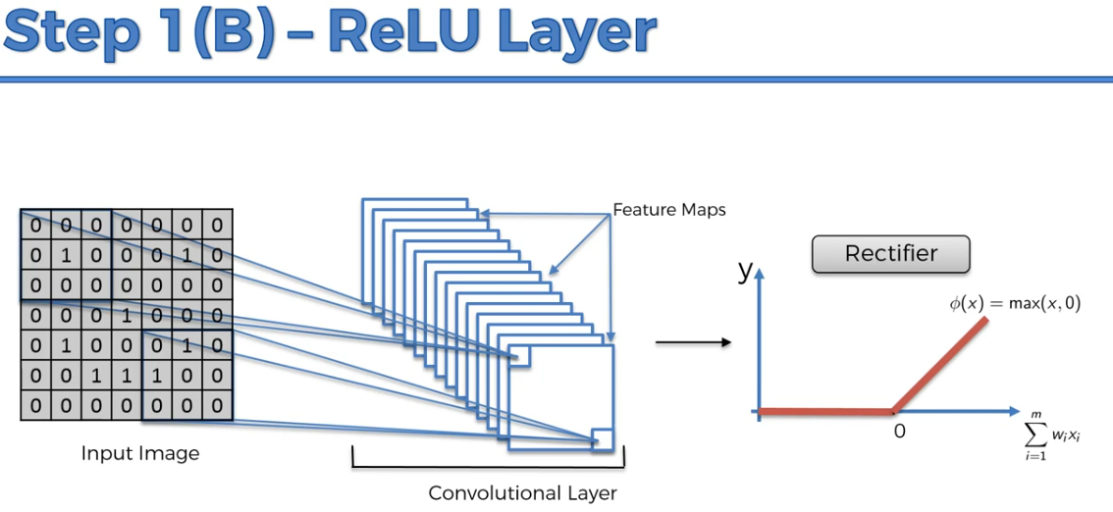

If the feature itself is a bit distorted, our neural network has to have some level of flexibility to be able to still find that feature. And pooling is all about this.

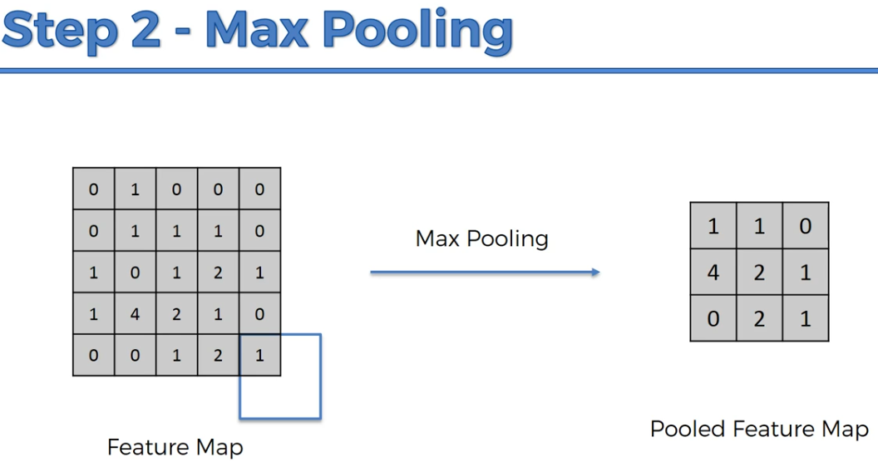

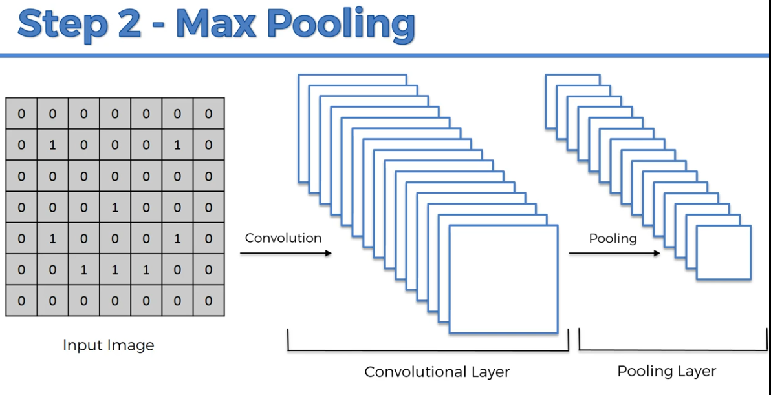

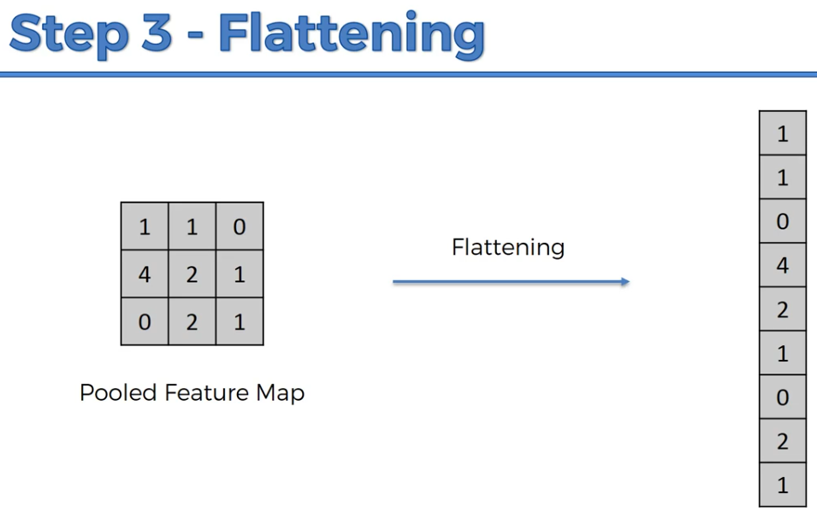

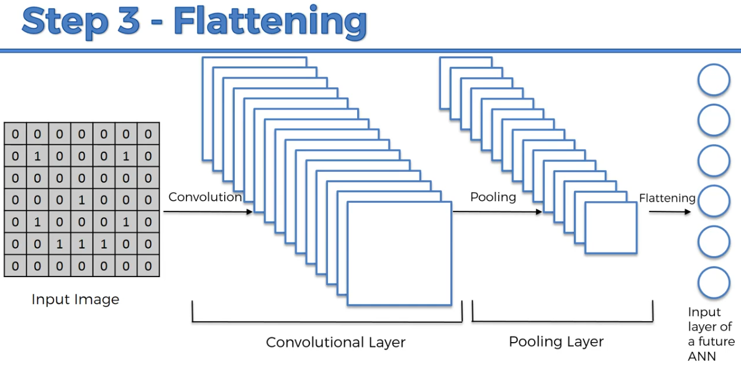

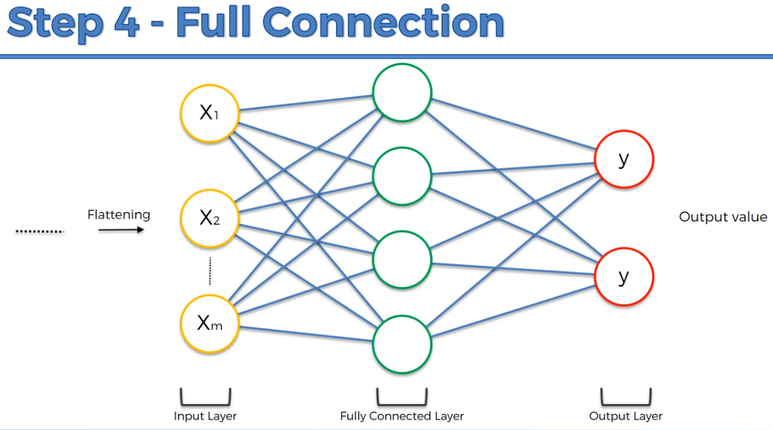

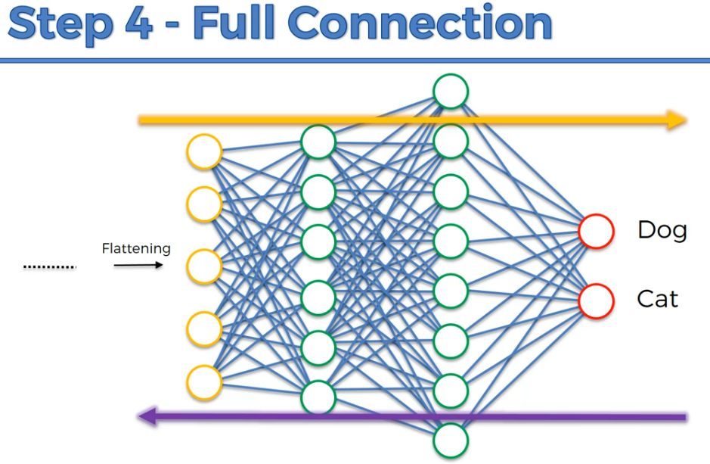

Here, back propagation will adjust weight and feature detectors.

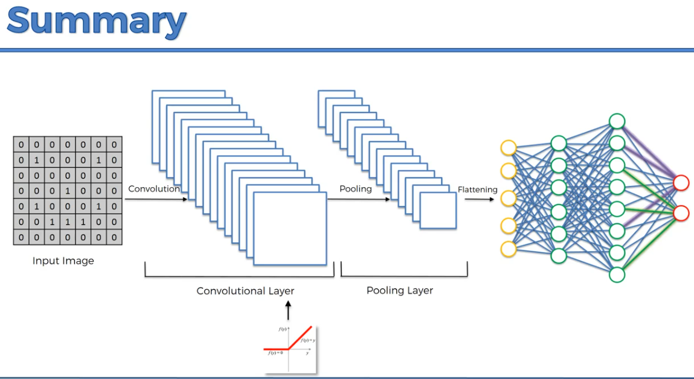

Dimensionality Reduction

There are two types of Dimensionality Reduction techniques:

Feature Selection

Feature Selection techniques are Backward Elimination, Forward Selection, Bidirectional Elimination, Score Comparison and more. (This is covered in Multiple Linear Regression)

Feature Extraction

Feature Extraction techniques:

Principal Component Analysis (PCA)

* It is unsupervised algorithm
* It is used for operations such as:
* Noise filtering
* Visualization
* Feature Extraction
* Stock market predictions
* Gene data analysis
* The goal is to detect the correlation between variables, reduce dimension if high correlation found

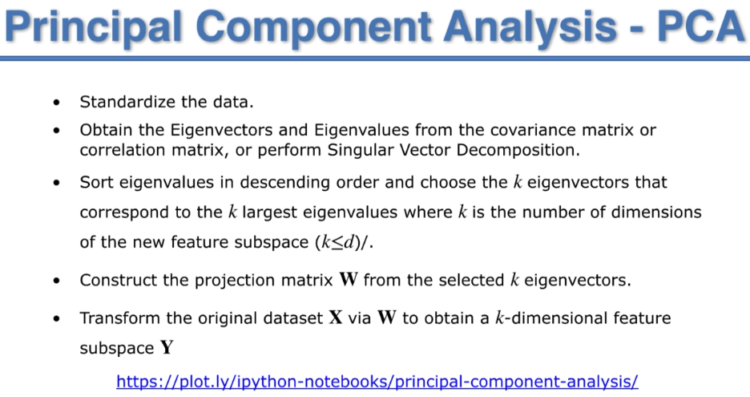

Linear Discriminant Analysis (LDA)

* It is supervised algorithm
* It also requires dependent variable
* Similar to PCA, the only difference is - here we are looking for maximum class separation

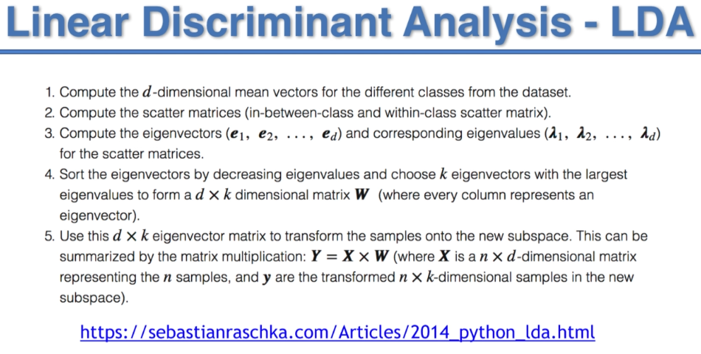

Kernel PCA

* Similar to PCA, just we are adding kernel to improve the performance

Quadratic Discriminant Analysis (QDA)

Model Selection

After we built our Machine Learning models, some questions remained unanswered:

1. How to deal with the bias variance trade-off when building a model and evaluating its performance?
2. How to choose the optimal values for the hyperparameters (the parameters that are not learned)?
3. How to find the most appropriate Machine Learning model for my business problem?

The following topics will answer these questions:

k-Fold Cross Validation

* Helps to measure the performance of models in the most relevant way
* Whenever performance for any ml model has to be evaluated, use k-fold cross validation

Grid Search

* Helps to identify the best possible hyper parameters

XGBoost

* This model can be used for both regression and classification
* It has become very popular because of its accuracy
* **Generally, it performs better than any of the regression or classification models**
* The default hyper parameters of XGBoost are sufficient, no need to tune it

Limitation of XGBoost

This is perhaps the fundamental flaw inherent in all tree-based models. It doesn’t matter if you have a single decision tree, a random forest with 100 trees, or an XGBoost model with 1000 trees. Due to the method with which tree-based models partition the input space of any given problem, **these algorithms are largely unable to extrapolate target values beyond the limits of the training data when making predictions**. This is usually not a huge problem in classification tasks, but it is definitely a limitation when it comes to regression tasks that involve predicting a continuous output.

**If the training dataset only contains target values between 0 and 100, a tree-based regression model will have a hard time predicting a value outside of this range.**

<https://towardsdatascience.com/why-xgboost-cant-solve-all-your-problems-b5003a62d12a>

What Tree-Based Models (like XGBoost) Are Good at Doing

XGBoost generally can’t predict the future very well, but it is well suited for tasks such as the following:

1. Classification problems, especially those related to real-world business problems such as fraud detection or customer churn prediction.
2. Situations in which there are many categorical variables.
3. Problems in which the range or distribution of target values present in the training set can be expected to be similar to that of real-world testing data.

What You Should Use Instead for Extrapolation

For forecasting or any machine learning problem involving extrapolation, **neural networks (especially recurrent neural networks with LSTMs are generally better for time-series forecasting tasks)** will generally outperform tree-based methods. Unlike tree-based algorithms, neural networks are capable of fitting any continuous function, allowing them to capture complex trends in data.

CatBoost

Meet CatBoost — the gradient-based model that is bound to beat out the power that LightGBM (a gradient-based model that uses tree-based learning algorithms) has to offer on specific problems.

CatBoost is a great self-tuning model to have in the toolkit whenever you want to **get the highest accuracy on datasets that have many categorical features**, which is usually the case with on-the-job problems.

CatBoost has some useful benefits, with easy implementation. Some of the main features of this competitive library are:

* even without parameter tuning the default parameters provide for great results
* **categorical features do not need pre-processing (auto converts categories into numbers)**
* quick computation
* increase in accuracy with less overfitting
* efficient predictions

Tips

* To practice ml models, you will need dataset, which can be obtained from <https://archive.ics.uci.edu/ml/datasets.php>